Experiment No. 4
Verification of System Properties: Linearity, Time Invariance, Causality and Stability
OBJECTIVE:
To verify the linearity and time-invariance properties of continuous-time and discrete-time systems using suitable input signals and system responses.
  - To analyze and classify continuous-time and discrete-time systems as causal or non-causal based on their input-output relationships.
  - To analyze and classify systems as memoryless or dynamic based on their dependence on present and past input values.
  - To verify the BIBO stability of given systems and classify them as stable or unstable for real-time automation applications.

To verify the linearity and time-invariance properties of continuous-time and discrete-time systems using suitable input signals and system responses.
Experimental Procedure:
- Select a representative CT or DT system.
- Generate two independent test inputs.
- Compute the individual system outputs.
- Form a combined input and compare its system output with the corresponding linear combination of outputs.
- Delay the input by t0 and compare the system response with the correspondingly delayed original output.
- Calculate numerical differences and classify the system.

MATLAB Coding:

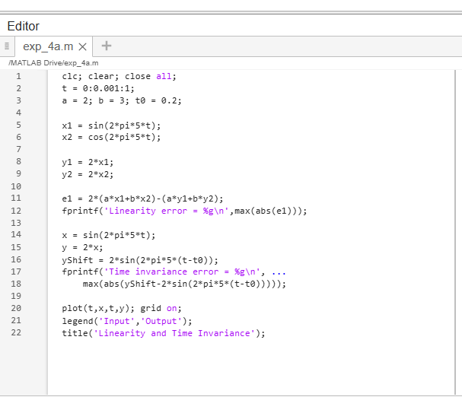
Results:
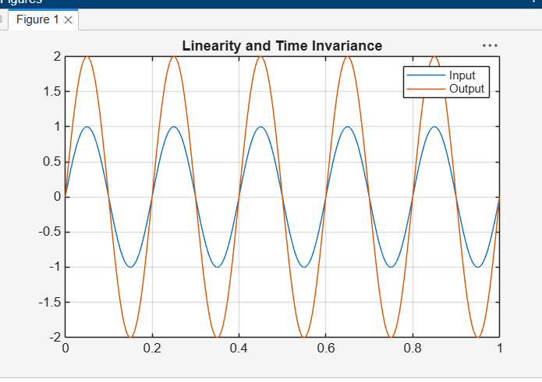

- To analyze and classify continuous-time and discrete-time systems as causal or non-causal based on their input-output relationships.

Experimental Procedure:
- Define a test sequence with a suitable index range.
- Implement the selected causal system.
- Implement the selected non-causal system.
- Inspect the input indices used to compute each output sample.
- Plot input and output sequences.
- Classify each system and justify the result from the dependency relation.
MATLAB Coding:
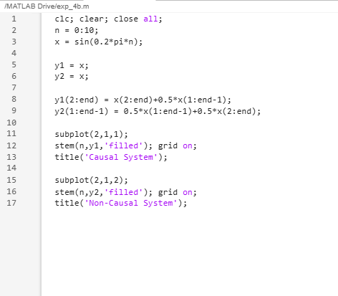
Results:
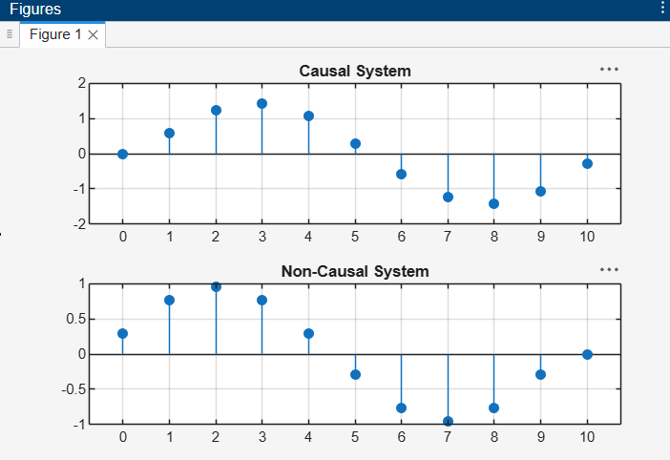
- To analyze and classify systems as memoryless or dynamic based on their dependence on present and past input values.

Experimental Procedure
- Define the representative systems.
- Generate a test input sequence or waveform.
- Evaluate the output at selected current instants/sample indices.
- Inspect which input values are required for each output.
- Classify each system as memoryless or dynamic.
- Record the mathematical justification and simulation observations.

MATLAB Coding:
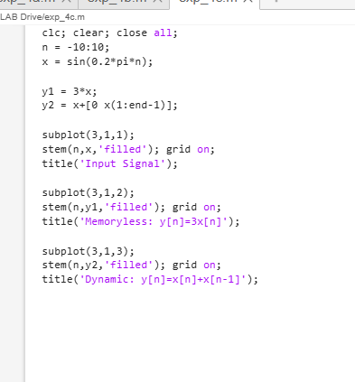
Results:
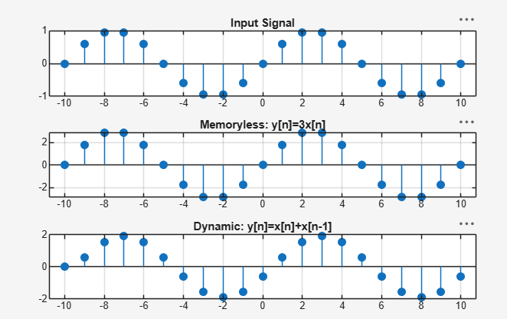
- To verify the BIBO stability of given systems and classify them as stable or unstable for real-time automation applications.
Experimental Procedure:
- Generate a bounded input such as a unit-amplitude sinusoid.
- Apply the input to the selected stable system and record the output.
- Apply the same input to the selected unstable system.
- Plot input and output over the simulation interval.
- Measure the maximum output magnitude and inspect whether it remains bounded.
- Classify the systems and discuss implications for real-time automation.

MATLAB Coding:
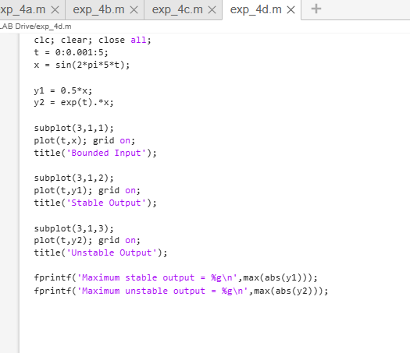
Results:
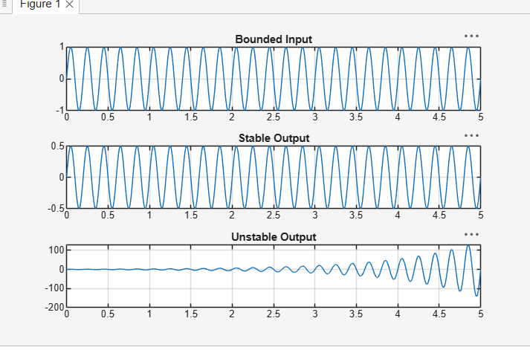

Conclusion:
The system properties were successfully verified and classified. Linearity, time invariance, causality, memory, and stability were analyzed. The results confirmed the system’s behavior for practical applications.

